Project Design Phase-1
Data Flow Diagram & User Stories
Date | 27 June 2025
Team ID | NM2025TMID00021
Project Name | Streamlining Ticket Assignment for Efficient Support Operations
Maximum Marks | 4 Marks

Data Flow Diagram (DFD):

A Data Flow Diagram (DFD) is a visual representation that shows how information flows within the support ticket system. It illustrates how data enters and leaves the system, how it is processed, and where it is stored.

In the project “Streamlining Ticket Assignment for Efficient Support Operations,” the DFD demonstrates the flow of data among users, the ticket management system, and the support agents. The diagram shows how new tickets are created, categorized, and automatically assigned to the appropriate support groups or agents based on predefined business rules and agent workload. This system helps reduce manual intervention, ensure balanced ticket distribution, and enhance service efficiency.

Example:

Flow

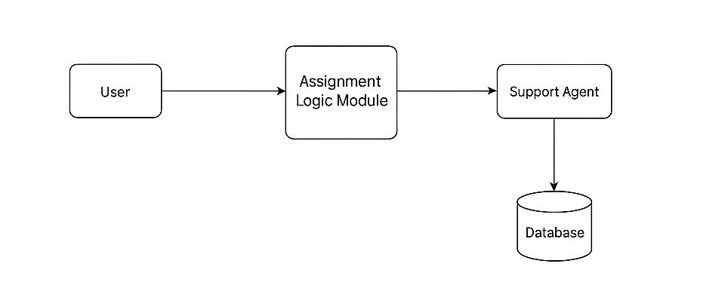
1. User submits a support request or ticket.
2. The system validates ticket details and categorizes the request.
3. Ticket data is sent to the Assignment Logic Module.
4. The automation rule assigns the ticket to an available agent based on expertise and load.
5. Notifications are sent to both the agent and the user.
6. The ticket and its status are updated in the databa

User Stories:

User stories describe how different roles interact with the ticket assignment system in simple, goal-focused language. These stories help ensure the system automates ticket routing while maintaining efficiency and accountability.

User Type | Functional Requirement (Epic) | User Story Number | User Story / Task | Acceptance Criteria | Priority | Release
Administrator | Ticket Configuration | STN-1 | As an admin, I want to configure ticket categories and define assignment rules for agents. | The system allows admins to create and edit assignment logic easily. | High | Sprint-1
System (Auto-Assignment) | Ticket Assignment | STN-2 | As a system, I must automatically assign tickets to available agents based on category and workload. | The system assigns tickets automatically without manual input. | High | Sprint-1
Support Agent | Ticket Handling | STN-3 | As a support agent, I want to view only the tickets assigned to me in real-time. | Assigned tickets appear instantly in the agent’s dashboard. | Medium | Sprint-2
Manager | Monitoring and Reporting | STN-4 | As a manager, I want to monitor ticket distribution and SLA compliance through a dashboard. | Dashboard displays assignment stats, agent workload, and SLA adherence. | Medium | Sprint-2

